
Education Bradford


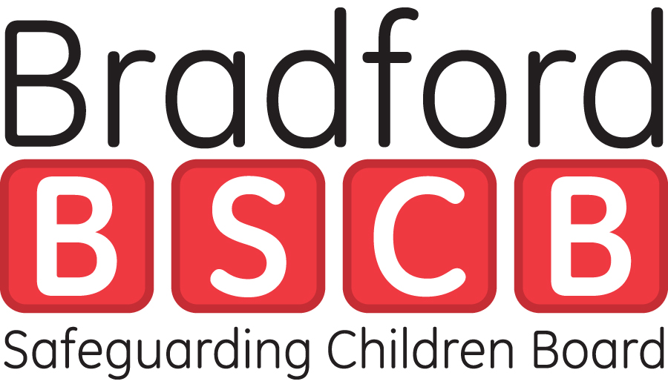
Department of Services to Children & Young People
Strategic Director’s Office - Aiming High for Children
Room 202
City Hall
Hall Ings
BRADFORD
BD1 1HY

Private and Confidential  Headteachers and Chairs of Governors of all Maintained Schools, Foundation Schools and Voluntary-Aided Schools | Tel: (01274) 431266  Fax: (01274) 431784  15 October 2009

Dear Headteacher / Chair of Governors

RE: Safeguarding Children

In light of recent changes to the Ofsted Framework in relation the safeguarding of children, it is essential that you review your policies and practices to ensure compliance. A Safeguarding Compliance Framework tool is attached to this letter as an aid to your self assessment. The changes to the Ofsted Framework took effect from September 2009 and means that within school inspections, there will be a focus on safeguarding; testing whether policy and practice is embedded throughout the school.

The effectiveness of safeguarding procedures will be reviewed as part of the overall judgement of Leadership and Management of the school. It is important to note that a judgement of inadequate, in relation to safeguarding procedures, is a “limiting” judgement and is likely to lead to an overall outcome of inadequate;

As you will be aware, the CRB Vetting Policy for Bradford schools and the DCSF Guidance on ‘Safeguarding Children and Safer Recruitment in Education’ requires school management to comply with a variety of procedures and checks in order to ensure the welfare and safety of children.

You are advised to refer to the ‘Briefing for section 5 inspectors on safeguarding children’ guidance, which can be downloaded from Bradford Schools Online. This is a very useful document which could easily be used as a discussion framework within the school’s senior management team. Your named person and governor, with responsibility for child protection (safeguarding), will also require access to this document. You are also advised to agenda this item at your next Governing Body meeting.

The Safeguarding Compliance Framework has been developed as a tool to support schools in assessing whether the safeguarding measures meet the requirements. The Framework covers critical aspects of safeguarding which would be part of an inspection, such as ethos, policies and procedures, recruitment, and training. In addition, it also covers the Single Central Record and documents which inspectors may expect schools to make available to them.

A copy of a Compliance Framework is attached to this letter. Please ensure that you use this tool in conjunction with the ‘Safeguarding checklist’ and the ‘Briefing for section 5 inspectors on safeguarding children’. All of the documents referred to are available on Bradford Schools Online for you to download. Other safeguarding advice and guidance can be found on the Bradford Safeguarding Children Board web-site.

Should you require any advice with regard to policy, procedure, or documentation referred to in the document, please contact Cathryn Whiteley, HR Business Support Manager.

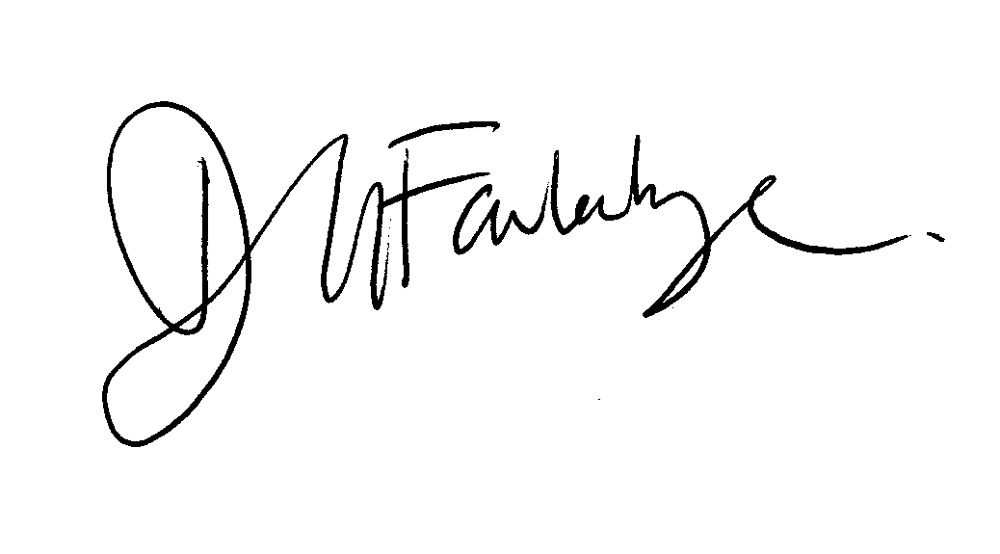
Yours Sincerely
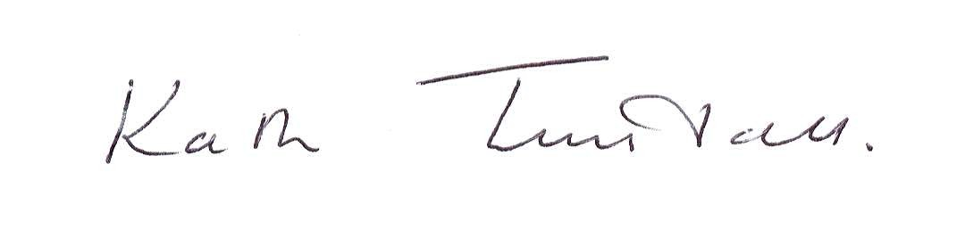

Kath Tunstall Denise Faulconbridge
Strategic Director Managing Director
Services to Children and Young People Education Bradford

Attached: Safeguarding Compliance Framework

